Social Media Video Content
The Facebook post copy below can be paired with a video from Hot Water Solutions’ resource library — we have provided suggestions with each post. First, download the video directly from Vimeo using the button located beneath the video title:
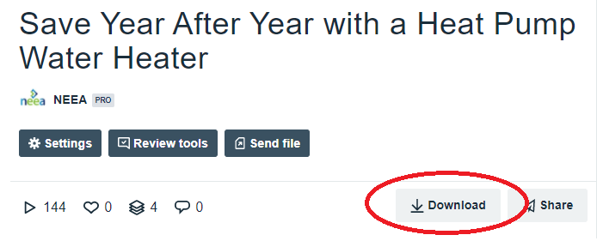
Choose the “HD 1080p” or “Original” size from the download menu. You may be prompted to choose the folder on your computer to save the video file to. If your file downloads automatically, go to your browser’s Tools menu and select Downloads and Show in Folder to locate the video file on your computer.
Then, in Facebook, create a video post and upload the video file from your computer. Use or adapt the copy below to accompany the video. We recommend that you include a call-to-action with your post after the suggested copy. If you have a heat pump water heater landing page on your website, you can say “Learn more at YourWebpage.com/HeatPumpWaterHeaters”; otherwise, consider directing people to call you or visit HotWaterSolutionsNW.org for more information.

- Hybrid water heaters are ultra-efficient, high-performing and reliable. Best of all, they’ll save you up to $3,600 in the long run.
[Pair with “Big Savings” video]

- If you’re spending more time at home, chances are you’re using more hot water. Upgrade to a hybrid water heater and you’ll lock in reliable water heating and substantially lower electric bills for years to come.
[Pair with “Reliable and Efficient Water Heating” video]

- A hybrid water heater gives you the same reliable hot water as a standard electric water heater, but the savings start right away with utility rebates and continue for years thanks to energy-efficient technology.
[Pair with “Save With Utility Rebates” video]

- It’s more important than ever to make sure your home is comfortable and functional. If you’re wondering whether it might be time to replace your old water heater, here’s a quick guide: hotwatersolutionsnw.org/news/how-old-is-my-water-heater
[Pair with “Better Choices” video]

- Think efficiency is the only thing hybrid water heaters have going for them? They’re actually able to provide more hot water per hour than similarly sized standard electric water heaters, they come with 10-year warrantees, and they’ll save you up to $3,600 in the long run.
[Pair with “Save Up to 60%” video]

- Switching to a hybrid water heater now won’t just save you money, it will also spare you from cold showers, flooding and emergency replacements. The average insurance claim for water damage due to a failed water heater is $4,000 — replacing your water heater now will help you avoid these messy situations altogether.
[Pair with “Water Heater Broken?” video]

- A conventional electric water heater uses more energy than a refrigerator, dishwasher, clothes washer and dryer combined. Hybrid water heaters work differently, using just a fraction of the energy and saving thousands of dollars on your electric bill.
[Pair with “Save Year After Year” video]

